**5. Implementation**

**5.1 Sample Screens**

**Home Screen**

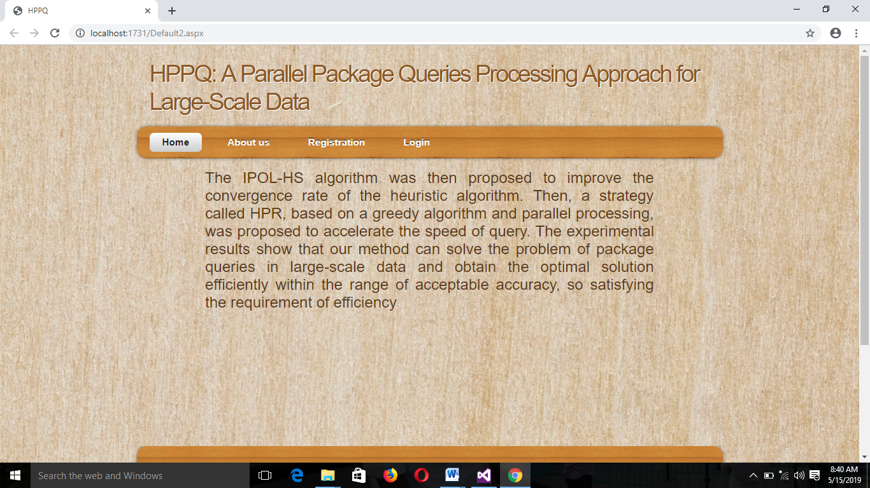

**Scree**n 5.1.1: Home Screen

**Description**: This screen contains the home screen of this system.

**About Us Screen**

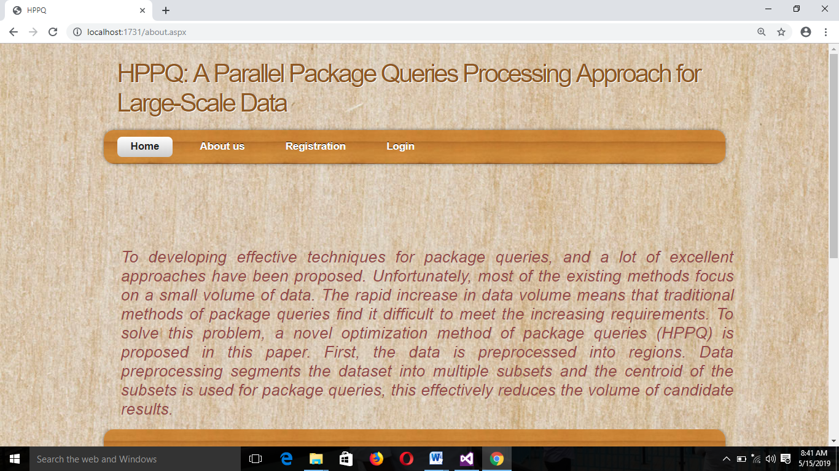

**Screen** 5.1.2: About us screen

**Description:** This screen contains the about us .In the page project description.

**Add User Registration details**

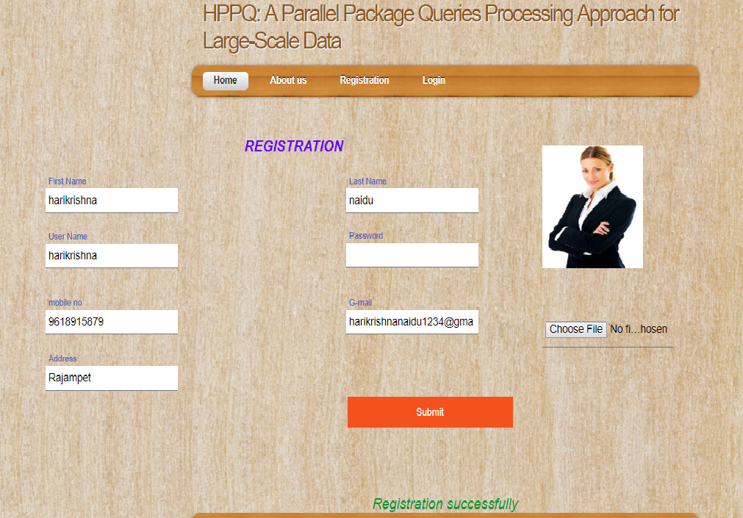

**Screen** 5.1.3: Add User Registration details

**Description:** These screens contain the details of user registration with all the details and choose the user profile. When enter the details and click on submit then information added successfully or registration successfully.

**User Login Screen**

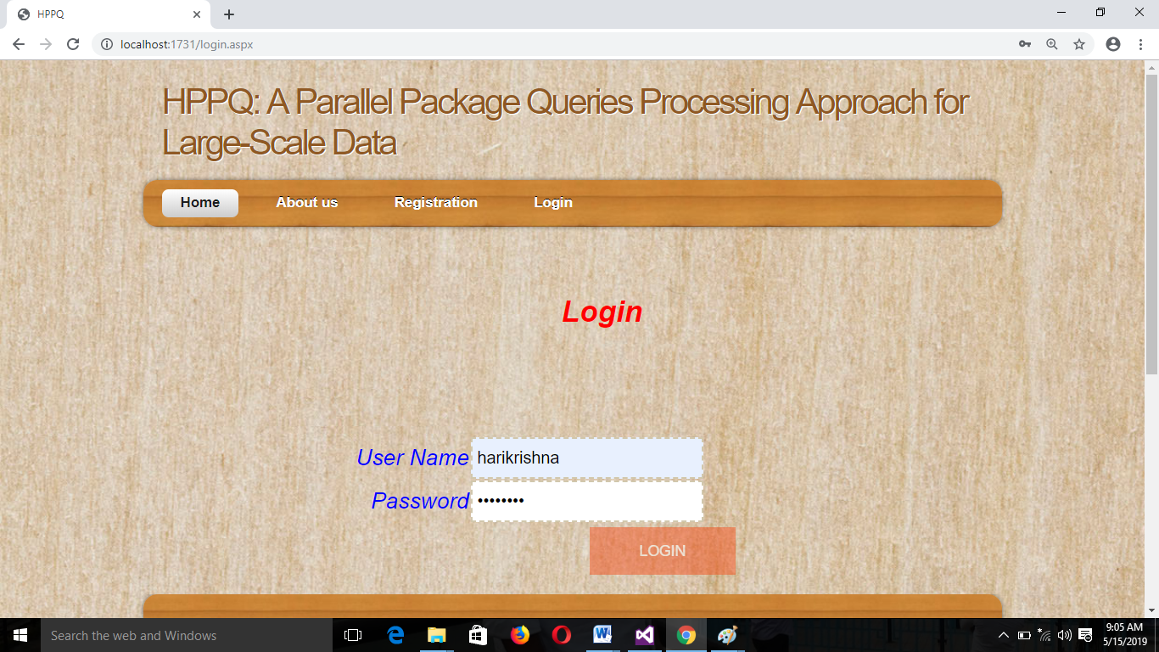

**Screen** 5.1.4: User Login Screen

**Description:** This screen contains the user login details. Whenever user tries to login then he must enter the correct login name and password.

**User Profile Home Screen**

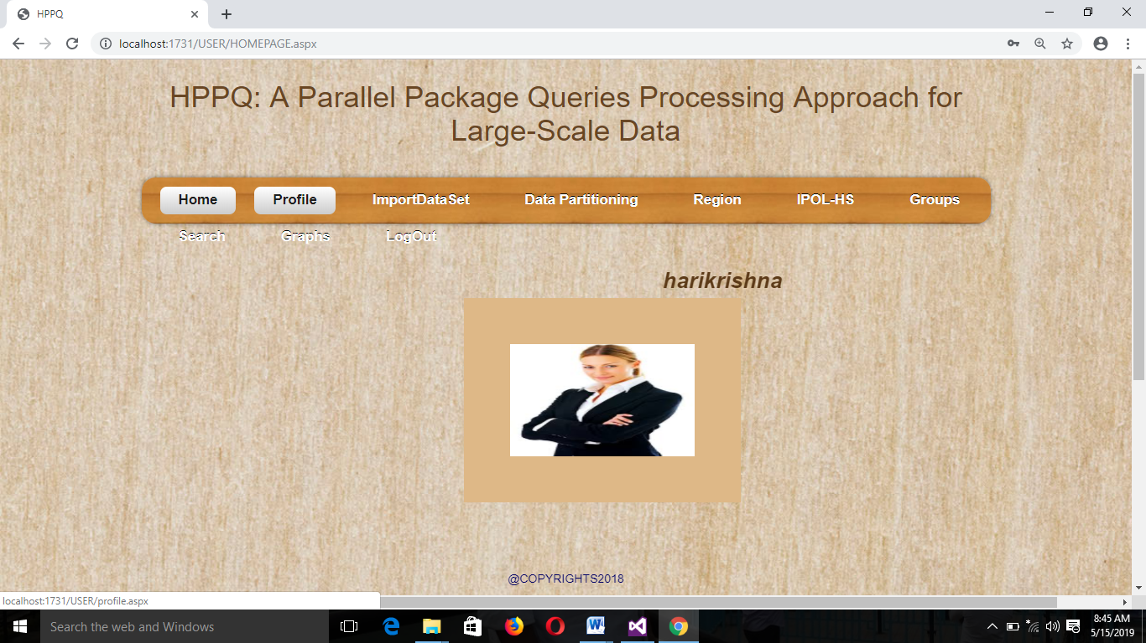

**Screen** 5.1.5: User Profile Home Screen

**Update User Profile Screen**

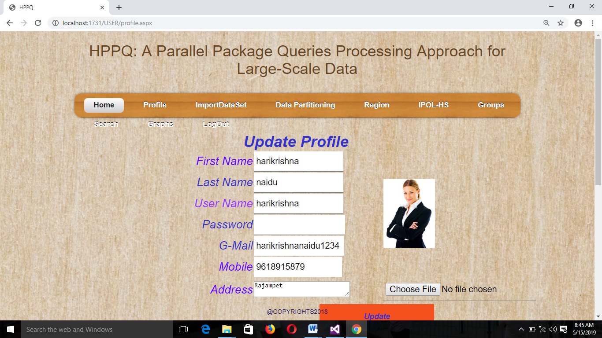

**Screen** 5.1.6: Update User Profile Screen

**Description:** This screen contains the update user profile.

**Importing Data set Screen**

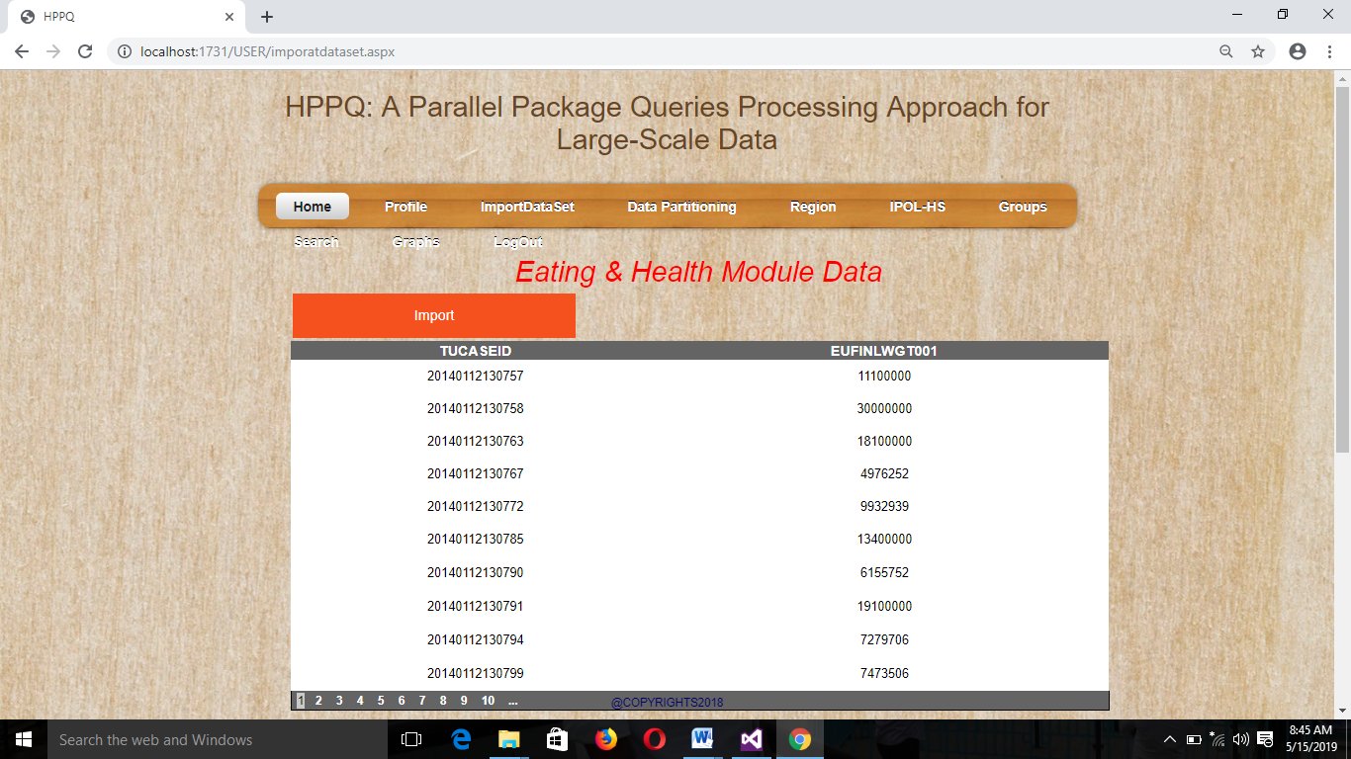

**Screen** 5.1.7: Importing Data set screen

**Description**: This screen contains the importing data set. To display health data.

**Data partitioning Screen**

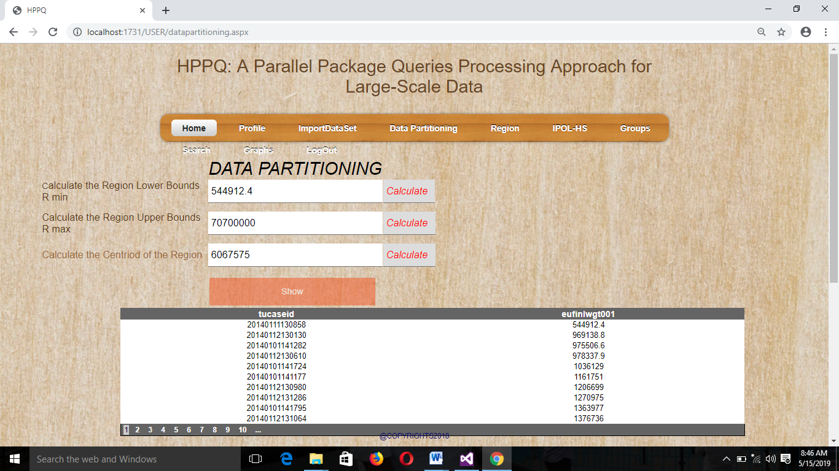

**Screen** 5.1.8: Data partitioning screen

**Description**: This screen contains the data partitioning. In this screen health data records are calculate the maximum, minimum and centroid. To click on the show button to display data.

**Regions Screen**

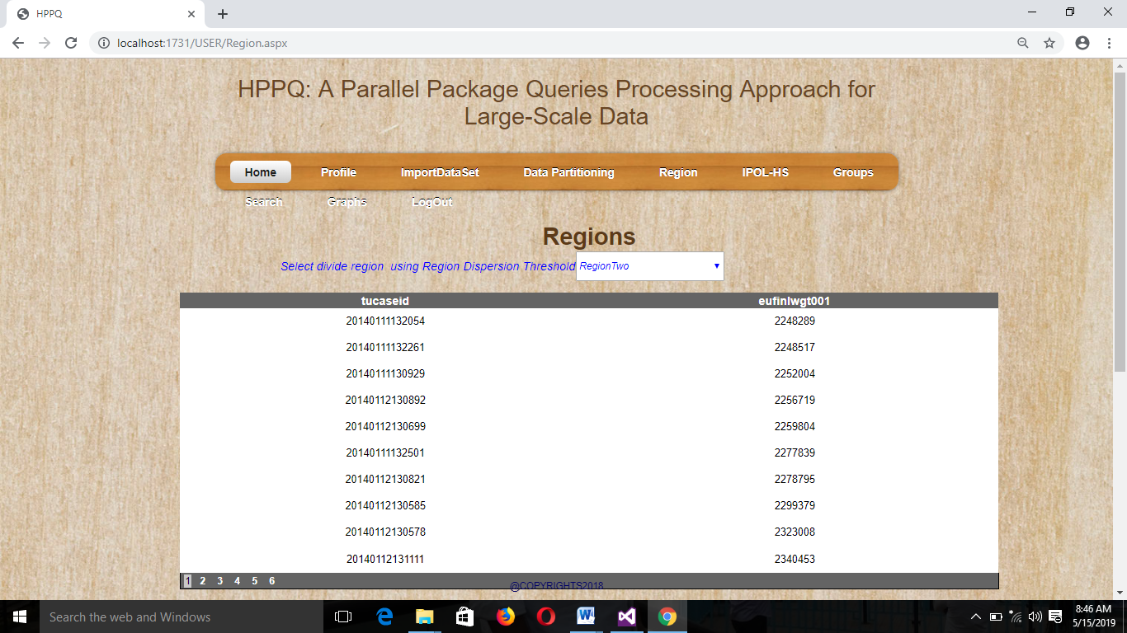

**Screen** 5.1.9: Regions Screen

**Description:** In this screen contains data is dividing in to regions, like region one, two, three, four and soon.

**IPOH-HS Screen**

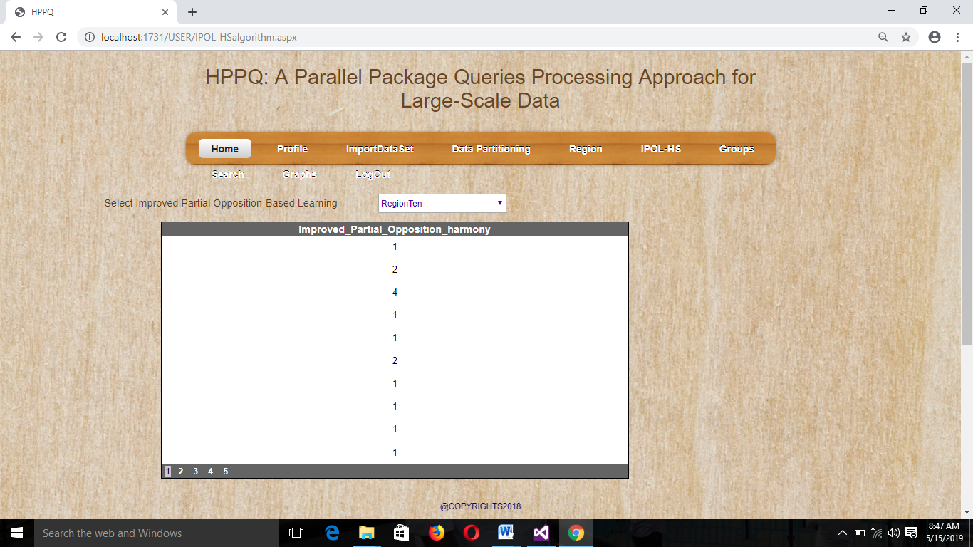

**Screen** 5.1.10: IPOL-HS Screen

**Description:** This screen contains apply the improved partial opposition harmony algorithm.

**Grouping Data Screen**

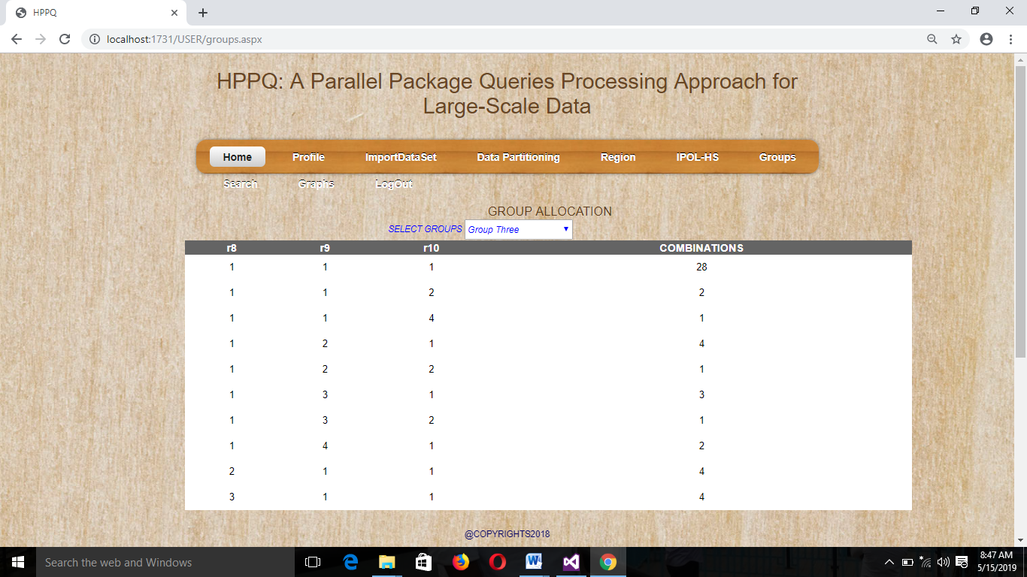

**Screen** 5.1.11: Grouping Data page

**Description:** This screen contains the grouping data, display groups data.

**User Search Data page**

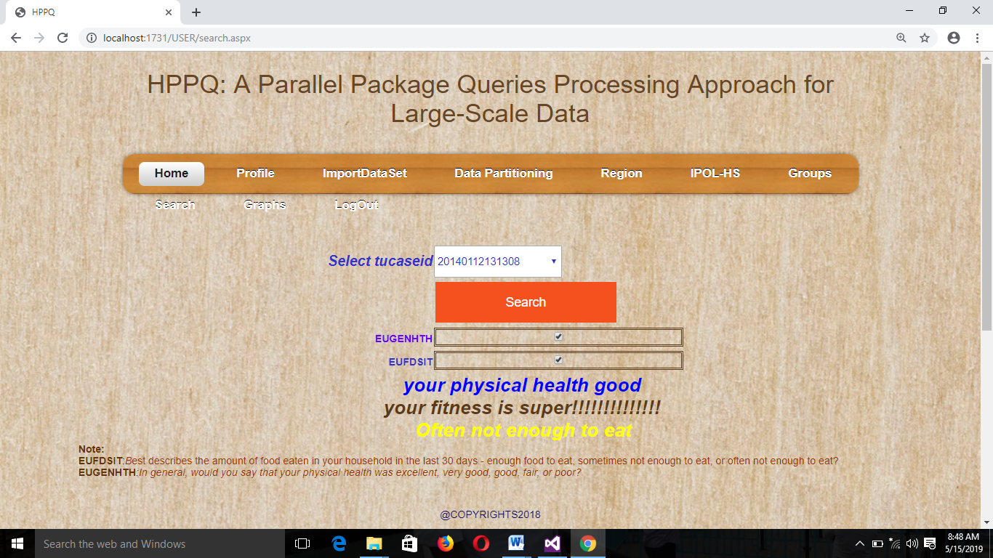

**Screen** 5.1.12: User Search Data screen

**Description:** In this screen user search the record , to display searching record and user health details.

**Graph page**

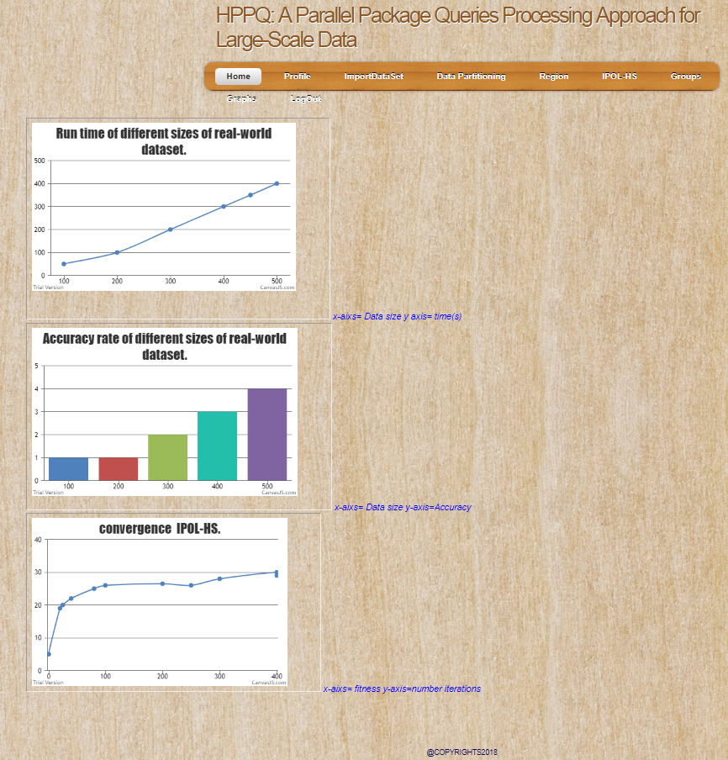

**Screen** 5.1.13: Graph screen

**Description:** This screen contains the user health data formed in graph.